`

Intelligent Machine for Fruit and Vegetable Grading

User Manual for Final Year Project

Supervised by: Mr. Muhammad Qasim
______________________________________________________________________________

Student Name: Asad Imran, Farjad Afzal, Usman Ahmed
______________________________________________________________________________

Reg Number: 2080255, 2080123, 2080145
_______________________________________________________________________________

Installation of Application:
The project is designed for the Windows platform and will provide users with “.exe” files. Once installed, the application will be available as a desktop application for grading fruits and vegetables.

Running of Application:
After installation, User have to connect the Arduino with their respective device (PC or Laptop) with the cable in order to perform grading process using hardware.

- Screen 1 - Login

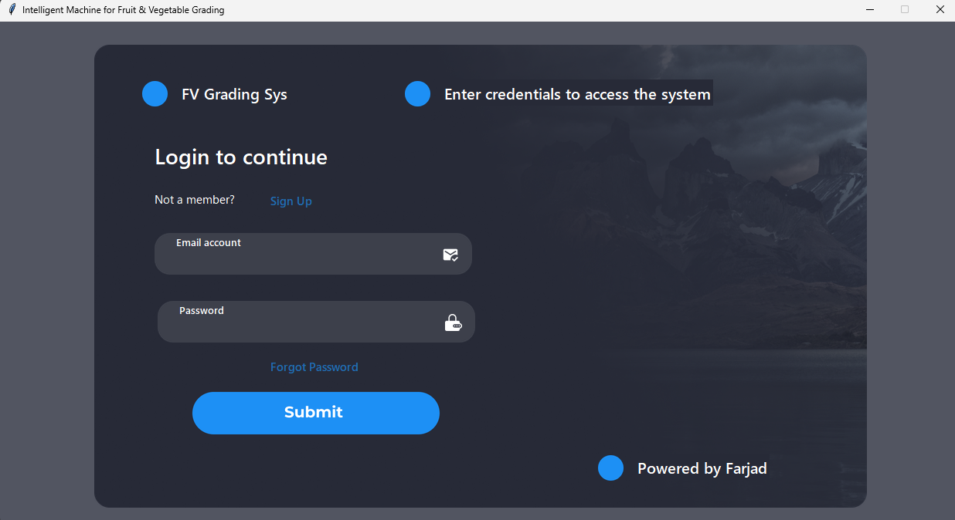

- If you have account, enter credentials.
- When application will be opened. It will be redirected to login page.
- Click on “Sign Up” if you don’t have account.

- Screen 2 – Sign Up

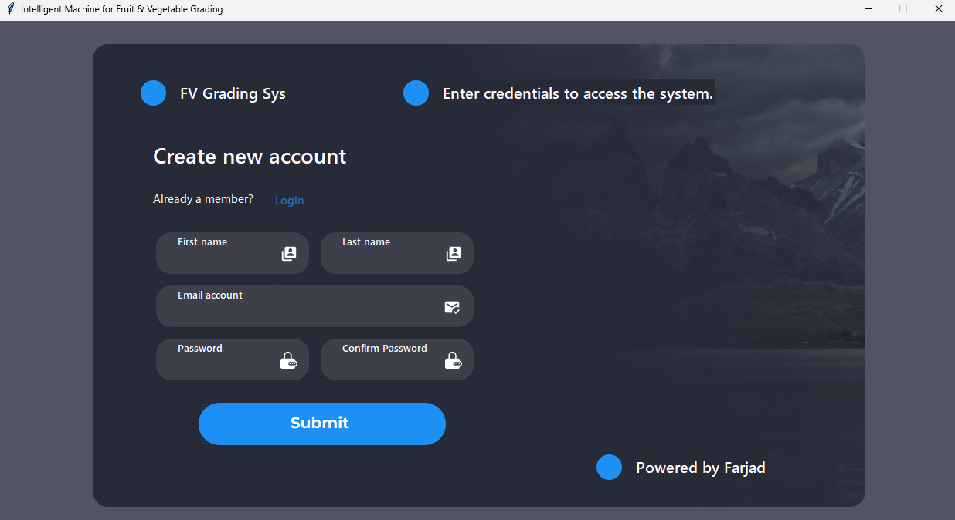

- Enter First Name, Last Name, Email and Password as input.
- After entering inputs, click the blue “Submit” button to sign up.
- After sign up the page will be redirected to Login Page where you can login your account.

- Screen 3 – Dashboard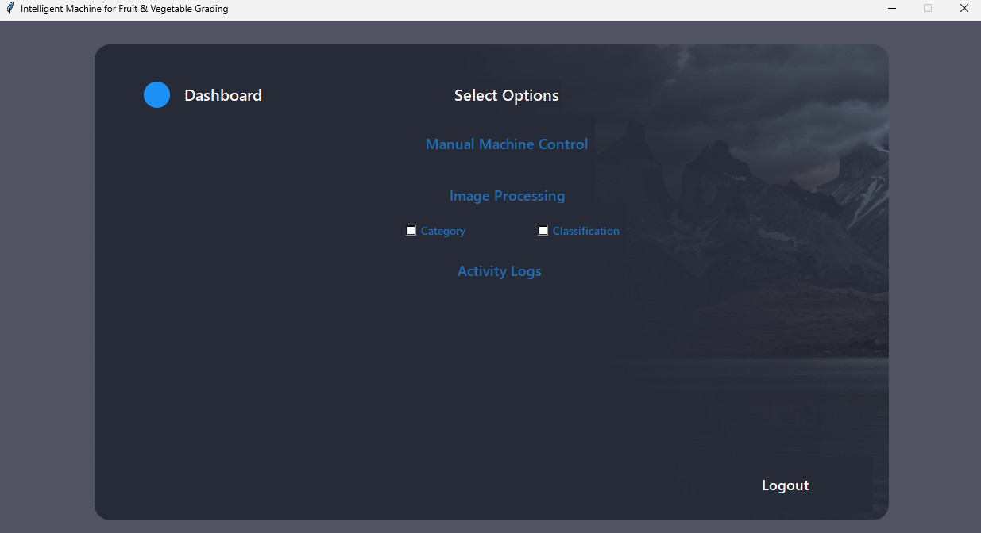

- After login there will be homepage where all query tabs will be shown.
- If you want to logout, click “LOGOUT” on right bottom on the screen.

- Screen 4 - Manual Machine Control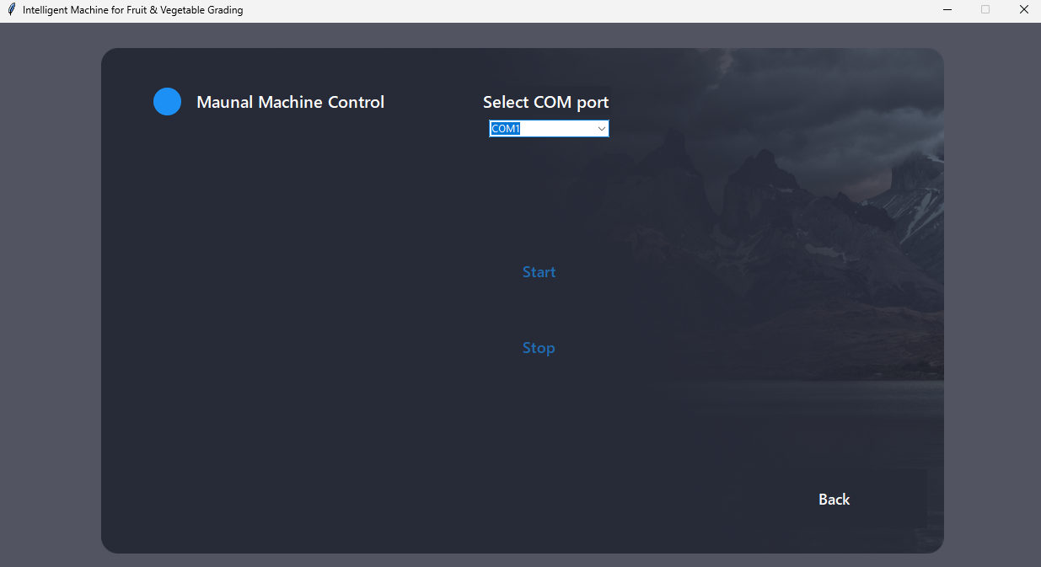

- Select the port where you connected the Arduino cable.
- Click on “Start” to start the conveyor and “Stop” to stop the conveyor manually.
- Click on “Back” in right bottom to go to previous screen.

- Screen 5 – Image Processing

- Click on the “Category” then click on “Image Processing” to get the category of the object.
- Click on the “Classification” then click on “Image Processing” to perform the classification.
- Click on the “Classification” and “Category” then click on “Image Processing” to perform both categorization and classification.
- Click on “Back” in right bottom to go to previous screen.

- Screen 6 – Activity Logs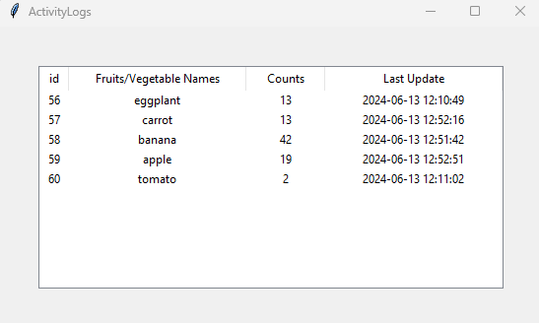

- Click on “Activity Logs” and a new tab opens that will show the activity performed recently.
- Click on “X” on right top to close the tab.

